Leadership Directory
Joseph Smith, Jr. (D&C 20:2; D&C 21:1):
___________, ___________, ___________, __________
Oliver Cowdery (D&C 20:3): ___________

Welcome to our new members
Hyrum Smith
Baptized June 1829, one of 8 witnesses
Peter Whitmer, Jr.
One of 8 witnesses
Samuel H. Smith
Baptized May 1829, one of the 8 witnesses
David Whitmer One of the 3 witnesses

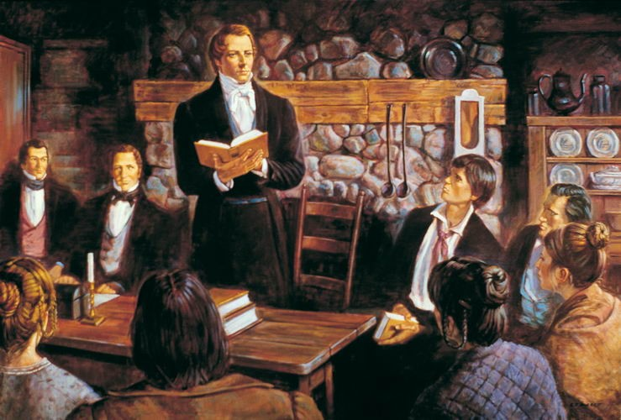

The Church of Christ
April 6, 1830
Fayette, New York
Home of Peter Whitmer, Sr.

Announcements

Baptisms tonight! All those desiring baptism, have repented, and are willing to take on the name of Christ are invited (D&C 20:31).
Joseph Smith Sr. and Lucy Mack Smith will be baptized later today. His son is very excited to see his father baptized in Christ’s restored church.
Upcoming conference: June 9th

Commandments
D&C 21:1 _________________________
D&C 21:4 _________________________
D&C 21:5 _________________________

Promises
D&C 21:6 _________________________
_________________________
_________________________

D&C 21:9 _________________________

Meeting Agenda

Solemn prayer
Sustain by common consent: Joseph Smith, Jr. and Oliver Cowdery as presiding leaders.

Ordain to office of Elder by laying on of hands:
Oliver Cowdery by Joseph Smith
Joseph Smith by Oliver Cowdery

Administration of the Sacrament

Confirmations for the Gift of the Holy Ghost & as members of the Church by laying on of hands: Hyrum Smith, Peter Whitmer, Jr., Samuel H. Smith, David Whitmer
Ordinations to other offices of the priesthood: David Whitmer and others
“The Holy Ghost poured out upon us to very great degree. Some prophesied whilst we all praised the Lord and rejoiced exceedingly. (History of the Church 1:77-78)
[At this meeting, Joseph Smith received the revelation now recorded in D&C 21].

